Coding Exercises

Exercise 1: Analyze a Noisy Signal
1. Add random noise to the signal from our example using np.random.randn().
2. Compute and plot the FFT.
3. Question: Can you still see the 50 Hz and 120 Hz peaks? How does noise appear in the frequency domain?

Answer:
Yes, you can still see the 50 Hz and 120 Hz peaks in the FFT plot. These frequencies represent the main components of the original signal, and they appear as sharp spikes in the frequency domain even after noise is added.
The noise appears as a broad, random background that spreads across many frequencies. Instead of distinct peaks, it creates small, irregular variations in amplitude, giving the frequency spectrum a 'fuzzy' appearance.

Code Output:

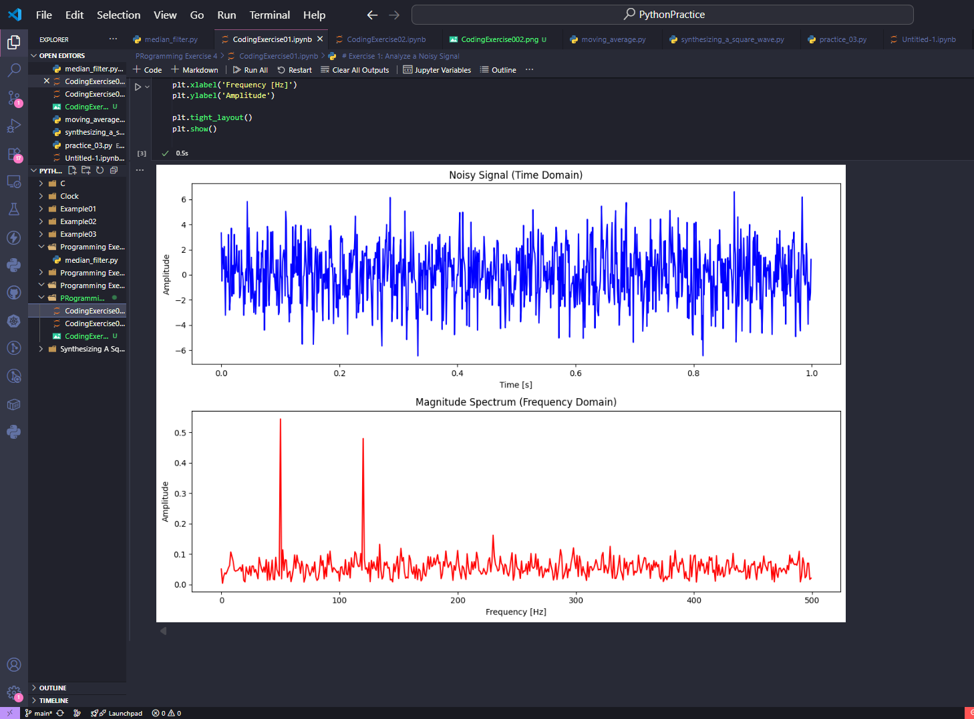

Exercise 2: Simple Noise Filtering
1. Take the FFT of the noisy signal.
2. In the frequency domain, 'zero out' the noise by setting small magnitude values to zero.
3. Apply the Inverse FFT (np.fft.ifft) to the filtered spectrum.
4. Plot the resulting time-domain signal. It should look much cleaner!

Answer:
After applying the simple noise filtering process, the resulting signal looks much cleaner and smoother in the time domain. By zeroing out small magnitude values in the frequency domain, most of the random noise is removed, leaving behind the dominant 50 Hz and 120 Hz frequency components.
In the frequency plot, the noise floor becomes lower and the peaks for the main frequencies stand out more clearly. The inverse FFT reconstructs a time-domain signal that closely resembles the original clean sine wave before noise was added.

Code Output:

